Introduction

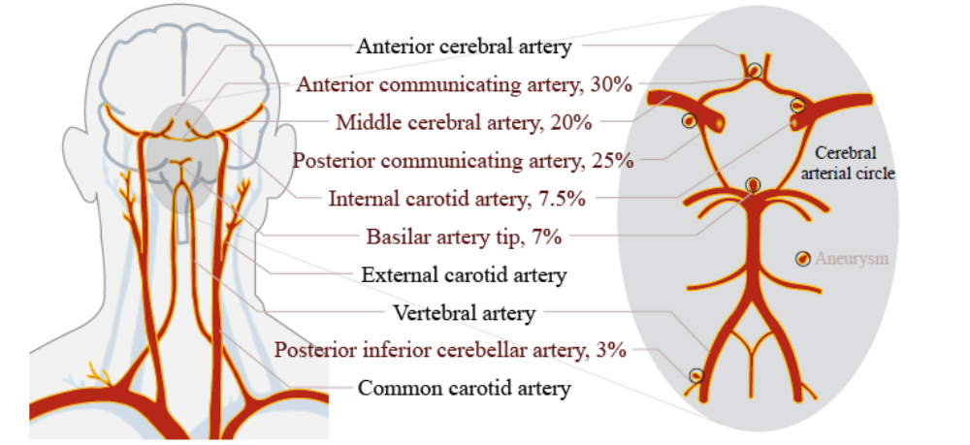
(Left) Arteries of the head and the neck [88, 32]

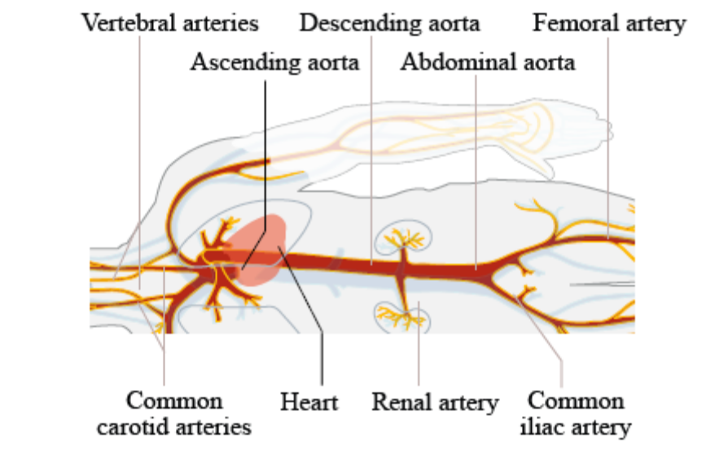
Major branches of the human arterial tree [88].

Literature Review
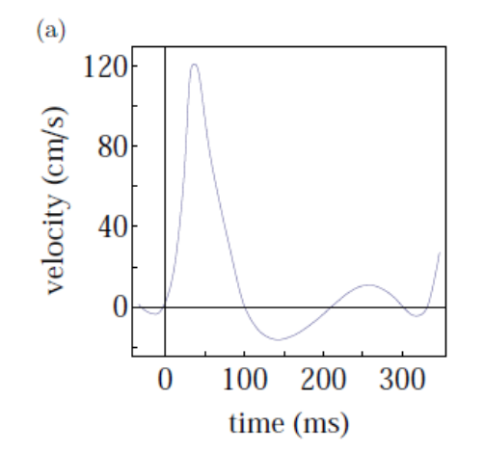
Velocity vs Time

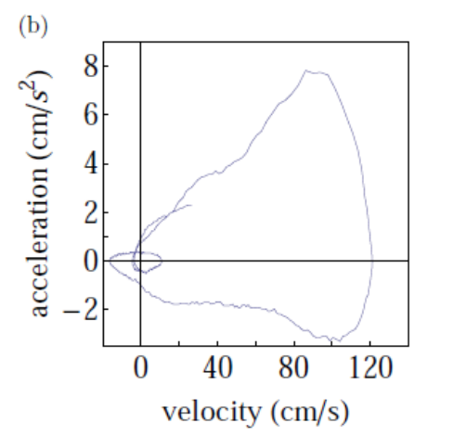
Acceleration vs velocity
Table details about types of motors
Title 1 | Title 2 | Title 3 | Title 4
Data 1 | Data 2 | Data 3 | Data 4
Data 5 | Data 6 | Data 7 | Data 8
Data 9 | Data 10 | Data 11 | Data 12

Second table

$${\left(x+a\right)}^{n}=\sum_{k=0}^{n}{\left({n \atop k}\right)x^{k}a^{n-k}}$$

$${\left(1+x\right)}^{n}=1+\frac{nx}{1!}+\frac{n\left(n-1\right)x^{2}}{2!}+…$$

Types of Motor

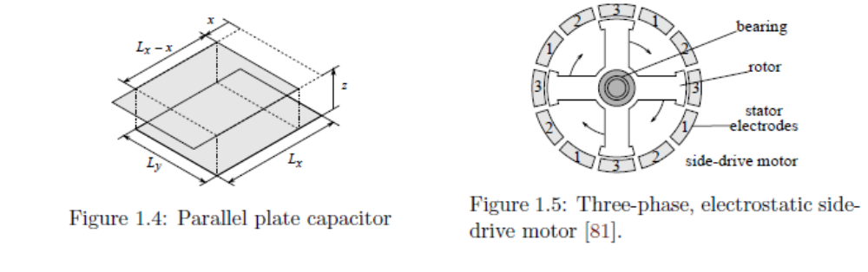
Parallel plate capacitor and Three-phase, electrostatic side-drive motor
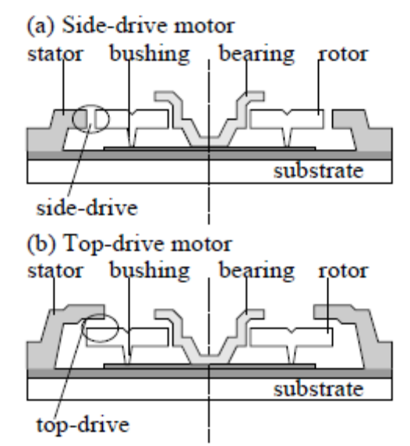
Side-drive motor

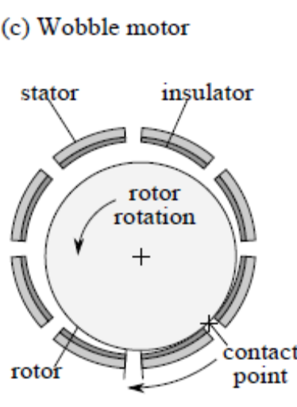
Wobble motor

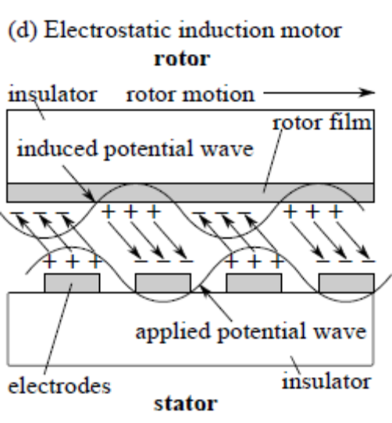
Stator

Results
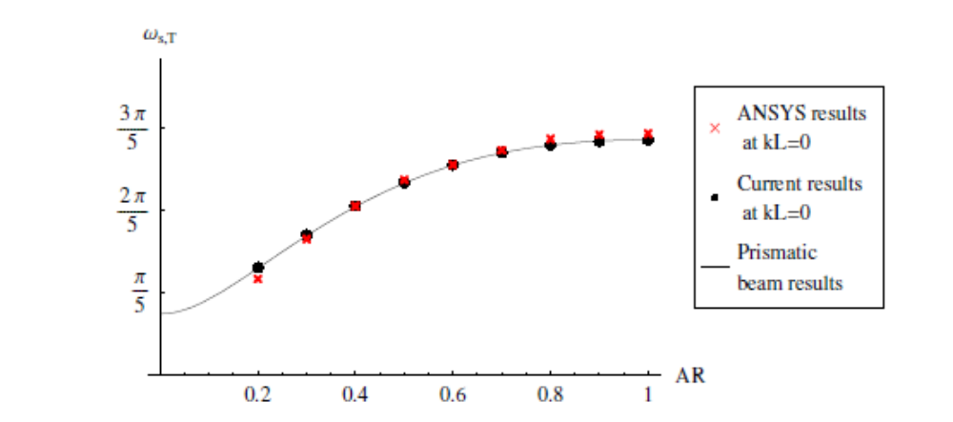
Graph ANSYS
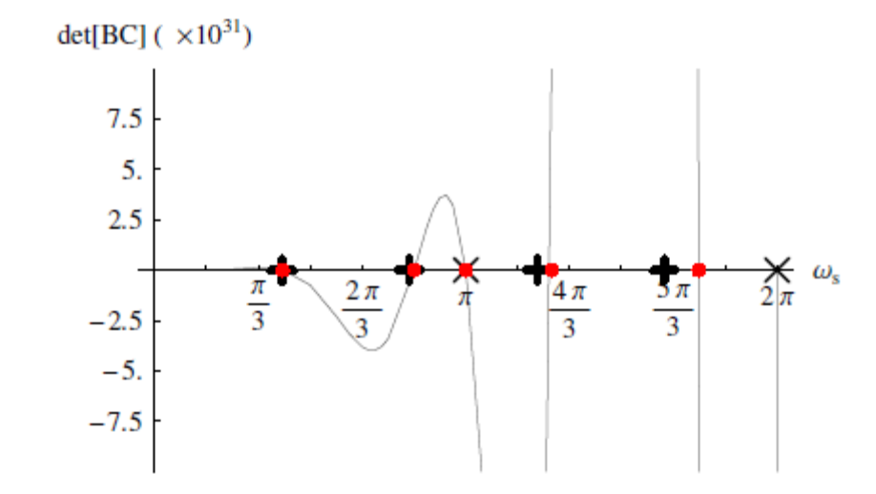
Graph details

- Set Caption – Please select one item first then the Position will appear and you can set
- To create a new label,
  - New Label
  - Set position
  - Choose Numbering
  - Can choose to exclude label from caption
- Can insert caption at any place, numbering will auto generate even though you insert in-between
- However if you delete an object and the resultant caption,
  - Select the whole document by selecting all,
  - Right click and update Field. Numbering for all caption will rearrange themselves.
- If you move rajah around, select all and update
- Update list of figure and tables separately
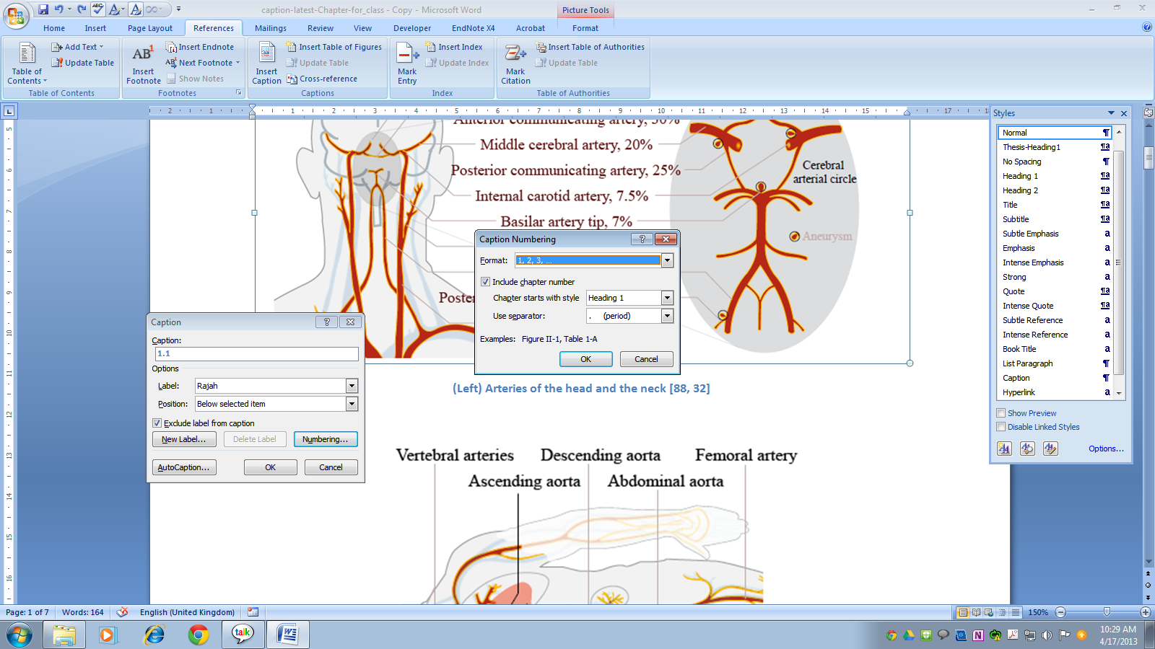

Example of a Figure dialog box

Bolt

