Monash HEARTS Volunteer Community
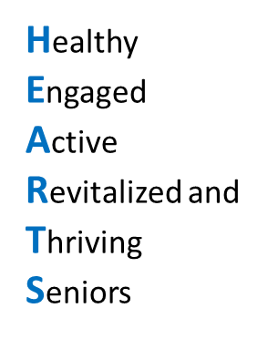
Who Can Join?
Individuals aged 55 and above.
Why Join?
- Make an Impact: Contribute to research aimed at improving quality of life.
- Be Part of a Vibrant Community: Connect with our Monash HEARTS.
- Enjoy Exclusive Opportunities: Participate in campus events, seminars, and engaging activities.

Your Voice Matters – Together, Let’s Shape our Life Tomorrow!

We deeply value your support in helping us make a meaningful impact through our research.
Personal Details
Name |  |  |  | Gender | Female Male
Date of Birth
Contacts
Mobile/Handphone |  |  | Home Telephone
E-mail |  |  | Home Address |  |  | _____________________________________________________________________
What is the best way to reach you?
Telephone Email Others (Please specify):

- I hereby consent to Monash University Malaysia’s staff members accessing my personal data (i.e., name and contact particulars) for research purposes.
Signature: Date:

