Table 1: Arteries where endovascular interventions are performed in humans (source: [92] unless noted otherwise
Site | Internal diameter  (mm) | Peak blood velocity  (cm/s) | Mean blood velocity  (cm/s) | Peak Reynolds number
Descending aorta | 8-18 | 25-250 | 10-40 | 3400
Femoral artery | 2-8 | 100-120 | 10-15 | 1000
Carotid artery | 2-8 | 100^{[55]} |  | 1250*
Arteriole | 0.01-0.08 | 0.5-1.00 |  | 0.09
Capillary |  | 0.02-0.17 |  | 0.001
* based on a diameter of 5 mm, peak blood velocity of 100 cm/s, a blood viscosity of 4 cP, and density of 1000 kg/m

Example:

Table 1: Arteries where endovascular interventions are performed in humans (source: [92] unless noted otherwise
Site | Internal diameter  (mm) | Peak blood velocity  (cm/s) | Mean blood velocity  (cm/s) | Peak Reynolds number
Descending aorta | 8-18 | 25-250 | 10-40 | 3400
Femoral artery | 2-8 | 100-120 | 10-15 | 1000
Carotid artery | 2-8 | 100^{[55]} |  | 1250*
Arteriole | 0.01-0.08 | 0.5-1.00 |  | 0.09
Capillary |  | 0.02-0.17 |  | 0.001
* based on a diameter of 5 mm, peak blood velocity of 100 cm/s, a blood viscosity of 4 cP, and density of 1000 kg/m

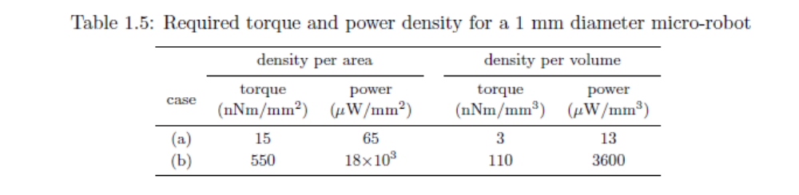
Table 2: Required torque and power density for a 1 mm diameter micro-robot
 | density per area |  | density per volume
case | torque  (nNm/mm²) | power  (μW/mm³) | torque  (nNm/mm²) | power  (μW/mm³)
(a) | 15 | 65 | 3 | 13
(b) | 550 | 18 X 10³ | 110 | 3600
 | density per area |  | density per volume
case | torque  (nNm/mm²) | power  (μW/mm³) | torque  (nNm/mm²) | power  (μW/mm³)
(a) | 15 | 65 | 3 | 13
(b) | 550 | 18 X 10³ | 110 | 3600
Example:

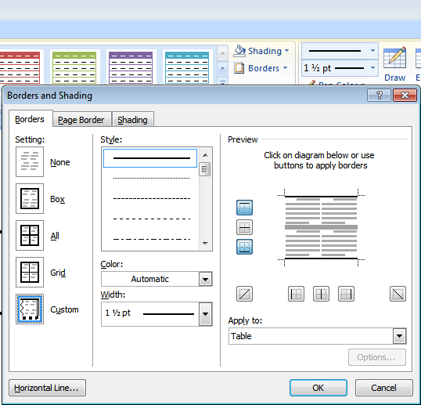
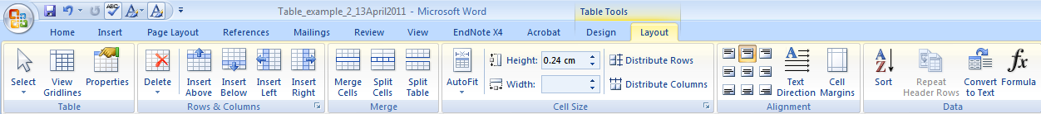
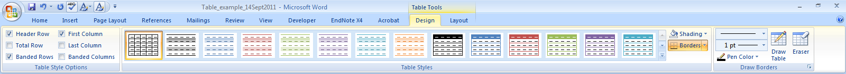
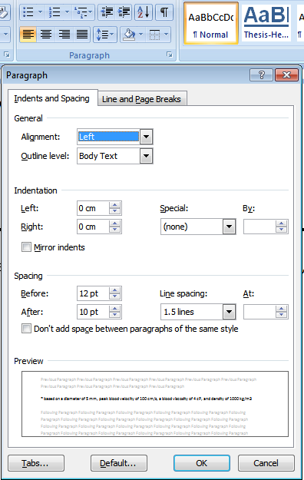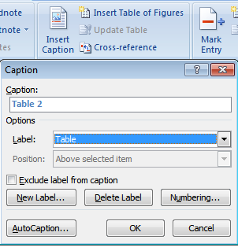
- Merge and Split Cells
- Insert rows above and below
- Autofit to window or to content
- Table Properties
- Set width and height
- Alignment of content
- Text Direction
- Cell margins
- Borders, set and thickness
- Paragraph indent spacing
- Insert Caption

- Borders and Shading
- Cell Margins
- Text Direction
- Merge Cells and Alignment

