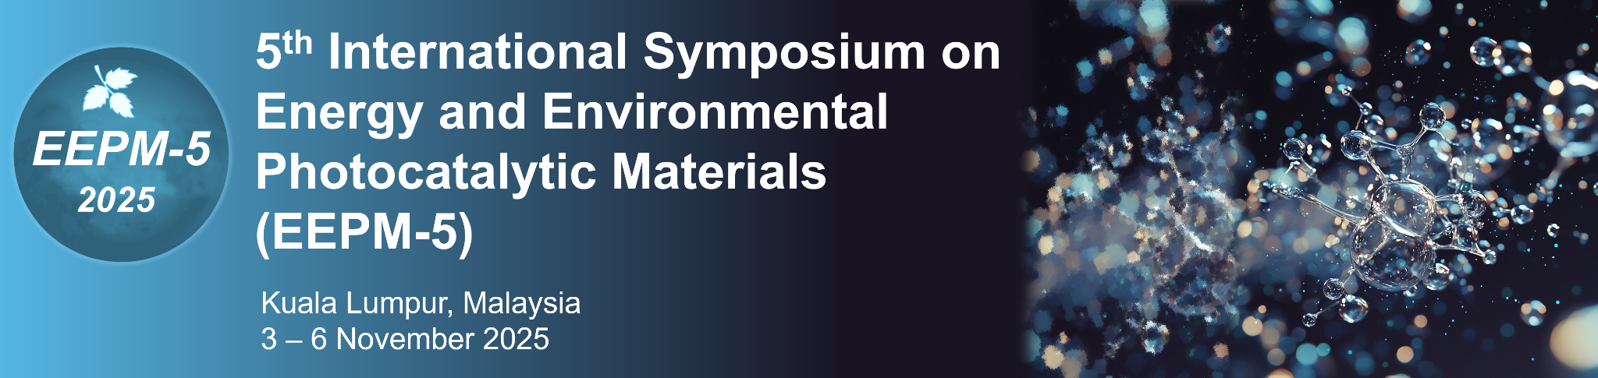

Guidelines for the Preparation of Abstract for EEPM-5

Author A.A.¹, Author B.B.², … and Author Z.Z.^{3*}

¹Affiliation of the first author, Department name, University name, State, Country

²Affiliation of the second author, Department name, University name, State, Country

³Affiliation of the last author, Department name, University name, State, Country

* Corresponding author Email address: ___

KEYWORDS: Photocatalysis; Advanced Functional Materials; Solar Hydrogen Harvesting

Abstract:

Please use this template to prepare your abstract for the 5th International Symposium on Energy and Environmental Photocatalytic Materials (EEPM-5). All submitted abstracts will be reviewed as per the relevance to the topic chosen, and a recommendation of the presentation mode (either oral or poster presentation) will be made afterward. The abstract should be prepared/submitted in Microsoft Word format. The content of the abstract should be written in either US or UK English (but not a mix of both types). The maximum page length of the abstract is two (A4 pages). The recommended font type and font size for the abstract content are Time News Roman font and 11 pts, respectively. Single spacing should be used between lines, and the main text should be justified on both sides.

Other specific guidelines are given below:

- Title: To be written in Times New Roman with 14 pts font size. Bold text and center alignment should be used.
- Authors: Include the surnames and given names of all the authors. No specific format of the author name to be followed. Please underline the registered/presenting authors, and include asterisk (*) on the corresponding author. Centre the text on the page.
- Affiliations: Provide the affiliations of all the authors. Label the author names with numbers given in subscript. Only the e-mail address of the corresponding author is to be provided. Centre the text on the page.
- Keywords: Provide up to five keywords, with each separated by semicolons.
- Tables and Figures: The inclusion of tables or figures is encouraged, but please do not provide more than two tables or two figures in the main body of the abstract. The content of the table or figure should not split over two separate pages. A table legend or a figure caption should be provided and numbered accordingly, for example: Table 1, Figure 2). The texts in legend or caption should be aligned to the centre. The resolution of the figure should be at least 300 dpi.
- Equations: The equations should be indented with the numbers in parenthesis and displayed on the right side.
- Acknowledgements: This section is optional. It may be included after the main body of the abstract but before the reference section.
- Citations and References: Follow the format of APA. The in-text citation shall be given in the format of (author, year), for example: (Davison & Conger, 2022), (Davison et al, 2022). The reference list is arranged in alphabetical order and is to be included at the last section of the abstract.

Acknowledgements: The authors thank the funder for awarding the grant.

References

Author, A.A., Author, B.B., & Author, C.C. (year of publication). Title of article. Journal Title, volume number(issue number), page–page. doi:xxxx
Author, A. A., & Author, B. B. (year of publication). Title of article. Journal Title, volume number(issue number), page–page. Retrieved from URL.
Author, A. A. & Author, B. B. (Year of publication). Title of work. Retrieved from URL
Author, A. A., & Author, B. B. (year of publication). Title of book (edition). Location of publication: Publisher.
Editor, A. A., & Editor, B. B. (Eds.). (year of publication). Title of book (edition). Location of publication: Publisher.

