Chapter 1 : Introduction
1.1 Miniaturization and micromotors
Miniaturization has been an important element of the technological advances that have occurred in the past _fty years. Since the invention of the integrated circuit in the 1950s, continual improvements in microfabrication techniques have enabled an exponential rate of decrease in the size of microelectronic components [59]. The ever greater diversity of higher performing electronic devices that can be produced at low cost enabled the proliferation of devices such as personal computers, laptops, digital cameras, mobile phones, and paved the way for the information technology revolution that has transformed our society [68]. The success of microelectronics have inspired e_orts to miniaturize systems from other _elds. For example, microelectromechanical systems (MEMS) based accelerometers and gyroscopes [93] can be found in a wide range of applications from tilt sensing smart phones [85], collision detection and skid control of automotive vehicles, to inertial navigation systems for weapons guidance systems [6, 11]. Research is also underway for novel biological applications, such as implantable MEMS that can monitor physiological parameters (e.g. pH, glucose, blood pressure) [17], and nanoporous membranes for the immunoisolation of pancreatic islet cell implants [24].
A major goal in the research of miniaturization technologies is the creation of autonomous miniature machines or micro-robots that could perform useful tasks under severe space constraints [20]. Some of the technologies needed for the development of micro-robots such as sensors [49] and controllers [38, 16] are already available at the sub-millimeter scale; however, signi_cant progress is still needed in areas such as actuation, power supply, control strategy, and data transmission to and from the robot.
1.2 Applications and requirements of micromotors
There are many important applications that would be enabled by `practical' micromotors with diameters in the 0.1{1 mm range. Motors at such scales would enable the development of micro-robots and miniature teleoperated tools that would give us access to locations with severe space constraints. For example, it would give us the ability to inspect the interiors of complex machines such as jet engines without the need for disassembly, or perform medical operations within the human body [68]. In this section, we discuss the application of microrobots to the _eld of medical surgery, which puts the motor research into context and sets performance targets for practical micromotors.
1.2.1 Minimally invasive surgery
From organ transplants to the the removal of tumors, modern surgery has helped save lives and cure previously untreatable diseases and conditions. However, there are many risks associated with surgeries due the invasive nature of the procedures. Signi_cant trauma is often involved simply to gain access to the area required for the intended operation. For example, in the case of open cholecystectomy (surgical removal of the gall-bladder), hospitalization is necessary for the patient to recover from the incision in their abdominal wall rather than the removal of the gall-bladder itself [53].
Following the introduction of endoscopic cholecystectomy in 1987 by Mouret, there has been a paradigm shift in the _eld of surgery to minimize the invasiveness of surgical procedures [67, 37]. Progress in minimally invasive surgery was made possible by the development of endoscopes equipped with miniature video cameras, high intensity lighting sources, and remotely operated surgical tools. The ability to perform surgeries through small incisions greatly reduced trauma and lead to a faster recovery following the operation. Despite its bene_ts to patients, the reduction on the surgeon's dexterity, visual and tactile feedback caused by the use of catheters or endoscopic tools have made it di_cult for minimally invasive procedures to be applied to complex surgeries [53]. Given the close connection between advances in minimally invasive surgery and the supporting technology, signi_cant breakthroughs in the _eld would be di_cult without the development of tools that can overcome these limitations.
To illustrate the potential uses of micromotors in minimally invasive surgery and their performance requirements, consider the following vascular diseases within the brain that are currently treatable with minimally invasive endovascular surgeries:
Arteriovenous malformations (AVMs) { abnormal connections between veins and arteries that can lead to serious illness and death especially if it occurs in the brain, due to intracranial haemorrhage, and epilepsy [4]. Treatment for the disease involves cutting o_ blood supply to the AVM by injecting a liquid embolic agent that is allowed to solidify within the abnormal connections [87].

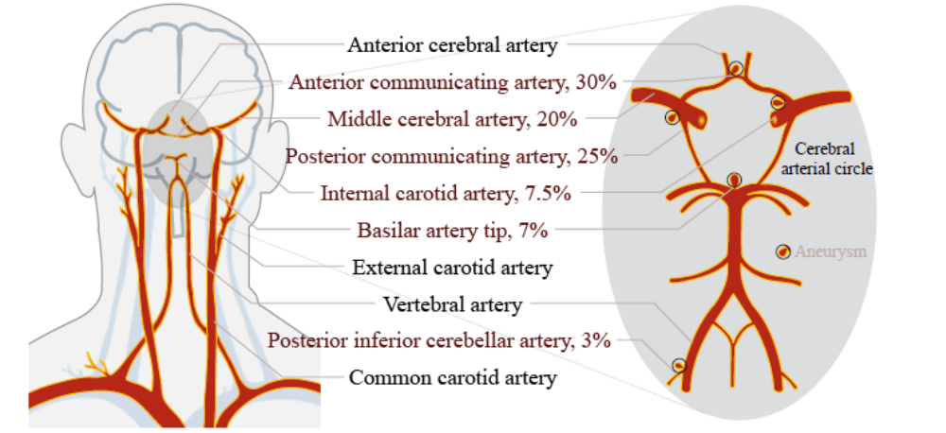
Figure 1: (Left) Arteries of the head and the neck [88, 32]

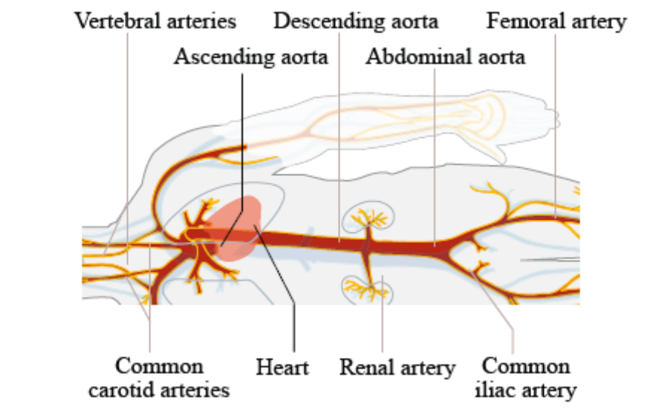
Figure 2 : Major branches of the human arterial tree [88].

Aneurysms { blood _lled dilation or outpouching of blood vessels frequently found in the cerebral arterial circle at the base of the brain (see Fig. 1.1). They are caused by a weakening of the vessel wall [10] which may rupture and lead to severe bleeding. One way to treat the disease is to insert a platinum coil into the aneurysm, initiating a blood clotting reaction that reduces the risk of rupture.
In both cases, the embolic agent or platinum coil are delivered via catheters (exible tubes), typically inserted into the femoral artery in the groin and passed through the aorta to reach the arteries of the brain (see Fig. 1.2). The navigation of catheters through the curves and branches of the vascular system to the desired location is a major task in endovascular surgeries. It is currently accomplished by the use of various catheters and guidewires with di_erent sti_ness and tip shapes; for example, guidewires with bent tips can be twisted to allow steering into
Table 1: Arteries where endovascular interventions are performed in humans
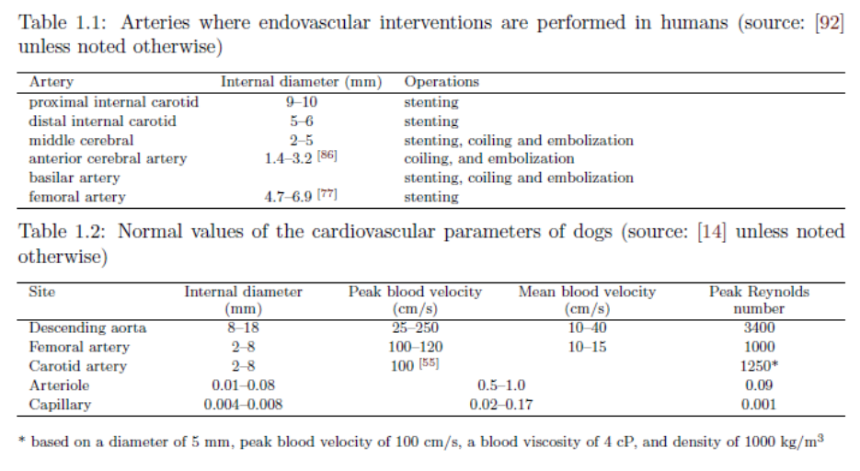

Arterial branches, which are subsequently swapped with sti_er exchange guidewires to enhance security of the access to a site [76]. The vascular system can be quite tortuous, requiring the guidewire-catheter apparatus to negotiate through multiple turns, resulting in the accumulation of frictional forces that may prevent further steering or advance of the catheter. The restricted maneuverability of the catheter tip also limits the procedures that can be performed and contributes to the failure of many operations. In a review of their experience with the treatment of aneurysms via coiling for 241 patients, Shanno et al. reported that 35 procedures were unsuccessful, 16 of which failed because the aneurysms could not be microcatherized, while 13 procedures failed because the coils were not securely placed within the aneurysm [78]. The di_culties experienced by current endovascular surgeons can be substantially eased by the development of motorized tools. In the ideal scenario, the micromotors would be su_ciently powerful to drive the propulsion system of free swimming endovascular micro-robots, giving surgeons access to locations far beyond the limits of current tools. However, even with less powerful micromotors, guidewires with motor actuated bent tips would substantially improve surgeons' ability to navigate their tools through tortuous arteries and arterial branches. In the next section, we will discuss the performance requirements for micromotors in endovascular micro-robots.
1.2.2 Estimated performance requirements
The requirements for the motor of a free swimming endovascular vehicle depends on the task it has to perform, the region of the vascular system it has to operate within, and the propulsion mechanism employed by the vehicle. These considerations determine (1) the constraints on the vehicle's geometry, (2) the blood viscosity and velocity pro_le the vehicle has to overcome, and (3) the power and torque needed to drive the propulsion system.

This is footnote 1

