Cross-reference - under Captions in References
Type – Figure, Table, Equation
Only Label and number
Choose with figure, table
To update, use the select all option, right click and select update field
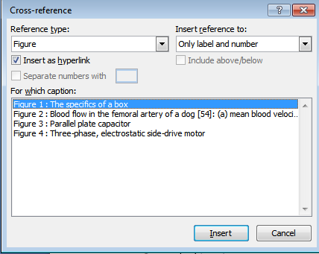
Figure 1: This is added later

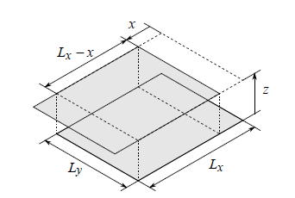
Figure 2 : The specifics of a box
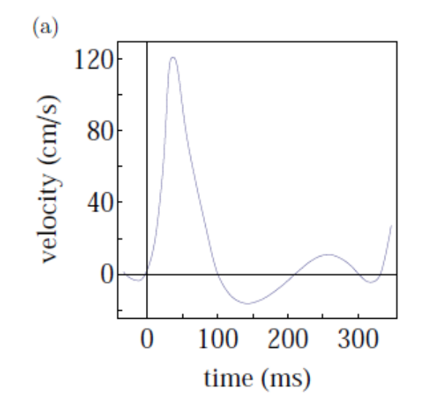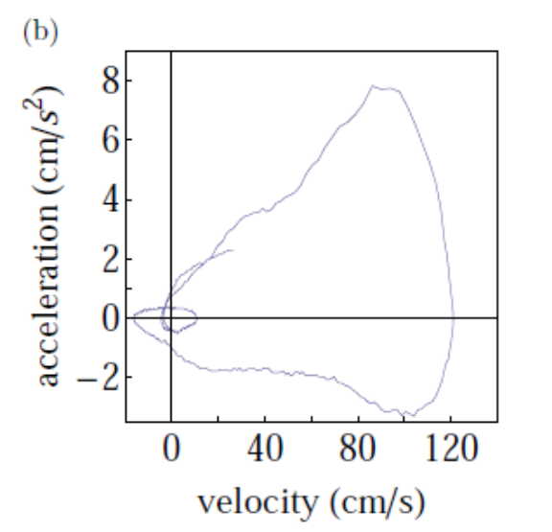
Figure 3 : Blood flow in the femoral artery of a dog [54]: (a) mean blood velocity versus time, (b) blood flow acceleration versus velocity.

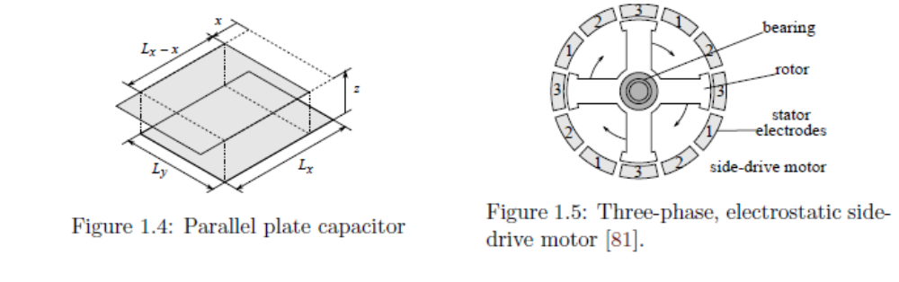  Figure 4 : Parallel plate capacitor – change title | Figure 5 : Three-phase, electrostatic side-drive motor

Figure 2 show the images of a plate capacitor. Figure 4 will show the same.
Figure 2 is repeated here. Figure 3 is showed here.

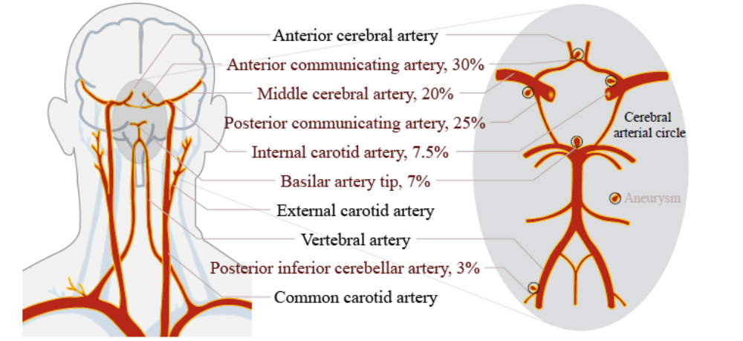
(Left) Arteries of the head and the neck [88, 32]

