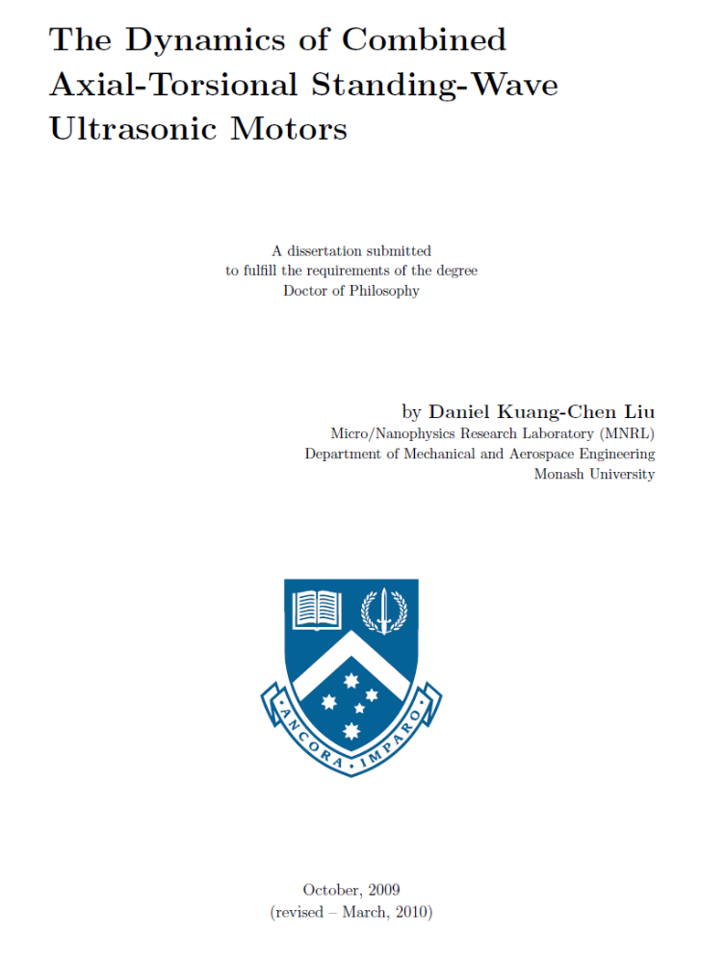

Acknowledgements
I began the life of a postgraduate student in 27 March 2006 with the _nancial support of: initially, the Australian Postgraduate Award, and later, the Sir James McNeill Foundation Postgraduate Scholarship. It was a di_cult journey _lled with obstacles, dead ends, and uturns. I was helped along the way by many people, without whom I would not have been able to reach the end. First of all, I would like to thank my supervisors Associate Prof James Friend and Dr Leslie Yeo for guiding me over the past 3.6 years. You have been incredibly patient with me as I repeatedly failed to meet our deadlines. I apologize for failing to deliver on the modelling of chiral carbon nanutubes as pretwisted beams, stick-slip behaviour of surface monolayers, and the chaotic rotation of nanoparticle _lled-droplets under acoustic excitation. Thank you for putting the pressure on me to publish, I know that you want me to succeed. I would like to thank members of Micro/Nanophysic Research Laboratory for their feedback on the various conference and research seminar presentations I had to give; I would like to thank DavidWajchman for the valuable experimental data he collected for the pretwisted beam CATS motor. I would like to thank my fellow postgraduate students Ming Kwang Tan, Paulo Jimenez, Shuo Li, Ricky Tjeung for their friendship and the entertaining lunch time conversations we have had; it was something I looked forward to everyday. I would like to thank Antonius Thambrin, Shaun Rimos, and Kien Bui from Hope church, Pastor Gong Ping Lin and Rev. Caleb Shen's family from Renewal Chinese Christian Church: your optimism, kindness and generosity are attitudes that I would like to imitate. Finally, I would like to thank my brother, Samuel, for putting up with the untidy housemate that I am; my sister, Esther, for insisting that we put e_ort into dinner preparations; and my parents, for your phone calls, letters, and visits from Sydney, I sincerely wish that I can reciprocate the care and love you have shown me.
Kuang-Chen Liu
Monash University
October 2009

Abstract
Piezoelectric ultrasonic motors have the potential to enable important applications such as endovasular surgical micro-robots due to their high torque and power density at the 0.1{1 mm diameter range. A type of ultrasonic motor that is suitable for miniaturization is the combined axial-torsional standing wave (CATS) ultrasonic motor that generates the CATS stator motion via pretwisted beam vibration converters. The operation of the motor involves (1) the generation of an ellipse-like stator tip trajectory when the pretwisted-beam stator is excited to vibrate in a CATS motion by a piezoelectric transducer, and (2) the transfer of frictional torque when the rotor is pressed against the stator tip. To gain a better understanding of the CATS ultrasonic motor, centimeter-scale prototypes were fabricated and tested to determine the characteristics of the motor design. Theoretical models of the pretwisted beam stator and the torque transfer mechanism were also investigated to help us predict the e_ects of various design parameters. The axial and torsional resonance frequencies of the pretwisted-beam stator needs to be matched for an e_cient generation of the CATS stator motion.
To help designers select the right analysis method for the design process, we investigated the validity of common pretwisted beam theories that assume the warping function of a pretwisted beam is locally identical to that of a prismatic beam. Through a scaling analysis of the equations governing the warping function of pretwisted beams|derived using semi-inverse method and Hamilton's principle| we obtained a set of criteria for checking the validity of the assumption. These criteria allow us to determine at what geometries the use of prismatic warping function will result in poor predictions of the axial resonance frequency and that alternative modelling methods are needed. Existing models of CATS motors ignore the vertical displacement of the rotor, predicting periodic behaviours that are contrary to the apparently random oscillations observed in the motor's steady-state operation. Our incorporation of the rotor's vertical motion results in a bouncing-disk model that explains various behaviours of the motor prototype, including the oscillations in the transient speed-time curve, and the e_ect of preload on stall torque and steady-state speed. The nonlinear dynamical system formed by the bouncing disk model shows that di_erent stator trajectories and interface properties can give rise to complex phenomena such as period doubling bifurcation, chaos, and extremely long period \chattering orbits". Knowledge of the location and basins of attraction for these orbits gives us detailed understanding of the motor's behaviour that will help designers improve the performance of CATS ultrasonic motor.

Table of Contents
Acknowledgements 2
Abstract 3
Table of Contents 4
List of Figures 5
List of Table 5
Chapter 1 Introduction 6
1.1 Miniaturization and micromotors 6
1.2 Applications and requirements of micromotors 7
1.2.1 Minimally invasive surgery 7
1.2.2 Estimated performance requirements 11
1.2.2.1 Geometric constraint 12
1.2.2.2 Velocity pro_le and properties of blood 12
Chapter 2 Literature Review 15
2.1 Comparison of small motor technologies 15
2.1.1 Electrostatic motor 16
2.1.2 Electrostatic motor 18
2.1.3 Electromagnetic motor 19
2.1.4 Piezoelectric motor 19
Chapter 3 Goals of our research 20
3.1 Stator dynamics 20
3.2 Stator-rotor interaction 21
Chapter 4 Motor characteristics: Prewtisted beam CATS ultrasonic motor 21
4.1 Stator dynamics: Vibration of pretwisted beams 22
4.2 Declaration for Thesis Chapter 3 23

List of Figures

List of Table

Introduction
In this chapter, we discuss our motivation for the investigation of sub- millimeter scale piezoelectric ultrasonic motors; we examine their potential applications, and compare the characteristics of di_erent micromotor technologies. The particular standing-wave ultrasonic motor design that is investigated in this thesis is then introduced, and the outline of the thesis is given.

1.1 Miniaturization and micromotors
Miniaturization has been an important element of the technological advances that have occurred in the past _fty years. Since the invention of the integrated circuit in the 1950s, continual improvements in microfabrication techniques have enabled an exponential rate of decrease in the size of microelectronic components [59]. The ever greater diversity of higher performing electronic devices that can be produced at low cost enabled the proliferation of devices such as personal computers, laptops, digital cameras, mobile phones, and paved the way for the information technology revolution that has transformed our society [68]. The success of microelectronics have inspired e_orts to miniaturize systems from other _elds. For example, microelectromechanical systems (MEMS) based accelerometers and gyroscopes [93] can be found in a wide range of applications from tilt sensing smart phones [85], collision detection and skid control of automotive vehicles, to inertial navigation systems for weapons guidance systems [6, 11]. Research is also underway for novel biological applications, such as implantable MEMS that can monitor physiological parameters (e.g. pH, glucose, blood pressure) [17], and nanoporous membranes for the immunoisolation of pancreatic islet cell implants [24].
A major goal in the research of miniaturization technologies is the creation of autonomous miniature machines or micro-robots that could perform useful tasks under severe space constraints [20]. Some of the technologies needed for the development of micro-robots such as sensors [49] and controllers [38, 16] are already available at the sub-millimeter scale; however, signi_cant progress is still needed in areas such as actuation, power supply, control strategy, and data transmission to and from the robot.
In this thesis, the challenge of actuating sub-millimeter scale micro-robots is addressed by examining a type of piezoelectric ultrasonic motor that we will refer to as the combined axialtorsional standing-wave (CATS) ultrasonic motor. The primary objective of our research is to obtain an in-depth understanding of the motor's actuation mechanism and the e_ects of its design parameters, which will help designers improve the performance of the motor.

1.2 Applications and requirements of micromotors
There are many important applications that would be enabled by `practical' micromotors with diameters in the 0.1{1 mm range. Motors at such scales would enable the development of micro-robots and miniature teleoperated tools that would give us access to locations with severe space constraints. For example, it would give us the ability to inspect the interiors of complex machines such as jet engines without the need for disassembly, or perform medical operations within the human body [68]. In this section, we discuss the application of microrobots to the _eld of medical surgery, which puts the motor research into context and sets performance targets for practical micromotors.

1.2.1 Minimally invasive surgery
From organ transplants to the the removal of tumors, modern surgery has helped save lives and cure previously untreatable diseases and conditions. However, there are many risks associated with surgeries due the invasive nature of the procedures. Signi_cant trauma is often involved simply to gain access to the area required for the intended operation. For example, in the case of open cholecystectomy (surgical removal of the gall-bladder), hospitalization is necessary for the patient to recover from the incision in their abdominal wall rather than the removal of the gall-bladder itself [53].
Following the introduction of endoscopic cholecystectomy in 1987 by Mouret, there has been a paradigm shift in the _eld of surgery to minimize the invasiveness of surgical procedures [67, 37]. Progress in minimally invasive surgery was made possible by the development of endoscopes equipped with miniature video cameras, high intensity lighting sources, and remotely operated surgical tools. The ability to perform surgeries through small incisions greatly reduced trauma and lead to a faster recovery following the operation. Despite its bene_ts to patients, the reduction on the surgeon's dexterity, visual and tactile feedback caused by the use of catheters or endoscopic tools have made it di_cult for minimally invasive procedures to be applied to complex surgeries [53]. Given the close connection between advances in minimally invasive surgery and the supporting technology, signi_cant breakthroughs in the _eld would be di_cult without the development of tools that can overcome these limitations.

To illustrate the potential uses of micromotors in minimally invasive surgery and their performance requirements, consider the following vascular diseases within the brain that are currently treatable with minimally invasive endovascular surgeries:
Arteriovenous malformations (AVMs) { abnormal connections between veins and arteries that can lead to serious illness and death especially if it occurs in the brain, due to intracranial haemorrhage, and epilepsy [4]. Treatment for the disease involves cutting o_ blood supply to the AVM by injecting a liquid embolic agent that is allowed to solidify within the abnormal connections [87].

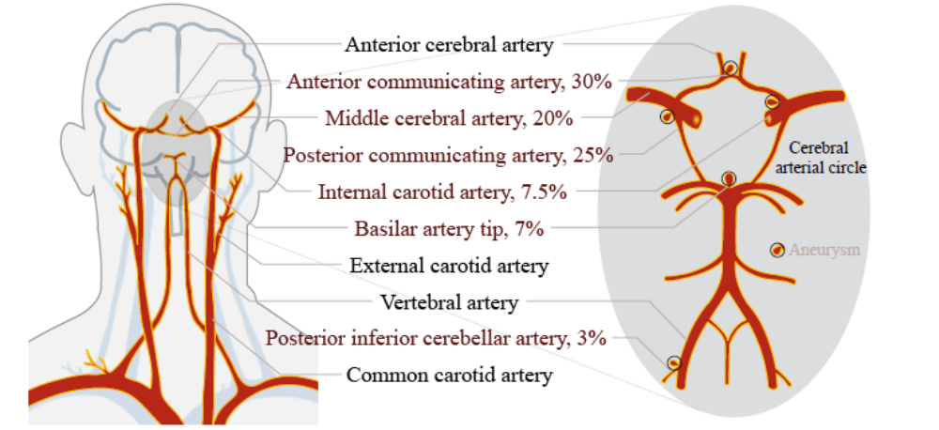
Figure 1 : (Left) Arteries of the head and the neck [88, 32]

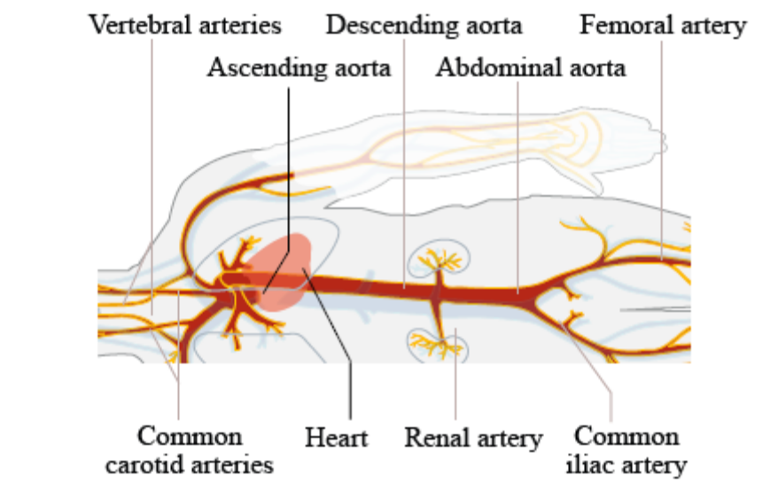
Figure 2 : Major branches of the human arterial tree [88]

Aneurysms { blood _lled dilation or outpouching of blood vessels frequently found in the cerebral arterial circle at the base of the brain (see Fig. 1.1). They are caused by a weakening of the vessel wall [10] which may rupture and lead to severe bleeding. One way to treat the disease is to insert a platinum coil into the aneurysm, initiating a blood clotting reaction that reduces the risk of rupture.
In both cases, the embolic agent or platinum coil are delivered via catheters (exible tubes), typically inserted into the femoral artery in the groin and passed through the aorta to reach the arteries of the brain (see Fig. 1.2). The navigation of catheters through the curves and branches of the vascular system to the desired location is a major task in endovascular surgeries. It is currently accomplished by the use of various catheters and guidewires with di_erent sti_ness and tip shapes; for example, guidewires with bent tips can be twisted to allow steering into

Table 1 : Arteries where endovascular interventions are performed in humans
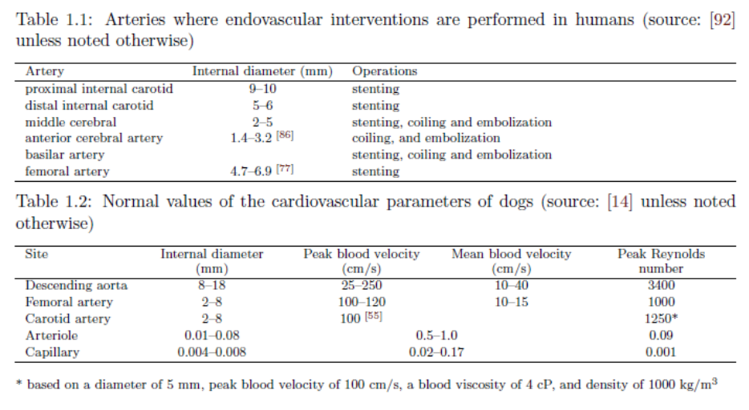

arterial branches, which are subsequently swapped with sti_er exchange guidewires to enhance security of the access to a site [76]. The vascular system can be quite tortuous, requiring the guidewire-catheter apparatus to negotiate through multiple turns, resulting in the accumulation of frictional forces that may prevent further steering or advance of the catheter. The restricted maneuverability of the catheter tip also limits the procedures that can be performed and contributes to the failure of many operations. In a review of their experience with the treatment of aneurysms via coiling for 241 patients, Shanno et al. reported that 35 procedures were unsuccessful, 16 of which failed because the aneurysms could not be microcatherized, while 13 procedures failed because the coils were not securely placed within the aneurysm [78]. The di_culties experienced by current endovascular surgeons can be substantially eased by the development of motorized tools. In the ideal scenario, the micromotors would be su_ciently powerful to drive the propulsion system of free swimming endovascular micro-robots, giving surgeons access to locations far beyond the limits of current tools. However, even with less powerful micromotors, guidewires with motor actuated bent tips would substantially improve surgeons' ability to navigate their tools through tortuous arteries and arterial branches. In the next section, we will discuss the performance requirements for micromotors in endovascular micro-robots.

1.2.2 Estimated performance requirements
The requirements for the motor of a free swimming endovascular vehicle depends on the task it has to perform, the region of the vascular system it has to operate within, and the propulsion mechanism employed by the vehicle. These considerations determine (1) the constraints on the vehicle's geometry, (2) the blood viscosity and velocity pro_le the vehicle has to overcome, and (3) the power and torque needed to drive the propulsion system.
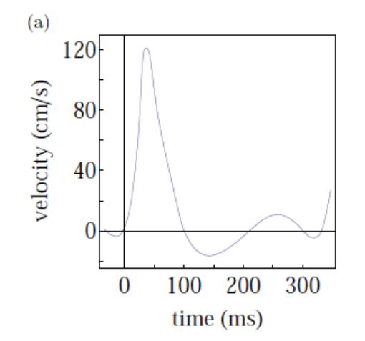
Figure 3 : Velocity vs Time

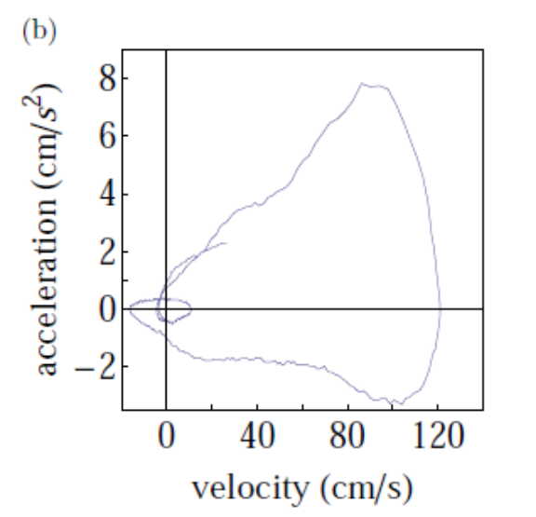
Figure 4 : Acceleration vs velocity

1.2.2.1 Geometric constraint
Using current catheter based operations as a guide, the capabilities expected of swimming microrobots include travelling to speci_c locations within the vascular system, making inspections and delivering various payloads such as the aforementioned coils and embolic agents, contrasting agents for X-ray imaging, and stents for treating stenosed (constricted) arteries. Table 1.1 lists some of the arteries that are currently accessed for treatments; the inner diameter di ranges from 10 mm in the internal carotid artery down to 1.4 mm in the anterior cerebral artery. In order to maintain a blood ow area of at least 20% relative to healthy arteries, the external diameter of micro-robots needs to be less than 0.2di if we allow for patients with moderately stenosed arteries of up to 50% reduction in inner diameter [7]. Under such considerations, the micro-robot diameter needed for accessing anterior cerebral arteries is on the order of 0.2 mm; this falls within the 0.1{1 mm range targeted by the CATS ultrasonic motor and is similar in size to guidewires currently used in the treatment of cerebral aneurysms [87]. As a comparison, the micro-robot diameter needed to access the arterioles (< 0:08 mm) and capillaries (< 0:008 mm) are up to two orders of magnitude smaller than arteries [29], beyond the scope the present investigation.

1.2.2.2 Velocity pro_le and properties of blood
The main components of blood are red blood cells and plasma, whose densities are 1095 and 1017 kg/m3 respectively [44]. Within the arteries, the hematocrit or percentage concentration (by volume) of red blood cells is typically of the order of 40, giving it a density of 1050 kg/m3. Blood is a shear-thinning, non-Newtonian uid that decreases in viscosity as shear rate is increased. Its viscosity is also sensitive to factors such as temperature and red blood cell concentration: decreasing with increasing temperature, and increasing with red blood cell concentration. For example, at 40 hematocrit and 37_C, blood viscosity varies from 5.8 to 3.8_10􀀀3 Pa.s when the shear rate is increased from 21 to 212 s􀀀1 [70]. For the purpose of estimating micromotor requirements, a viscosity of 4_10􀀀3 Pa.s will be used.

Table 2 : Materials properties and geometry
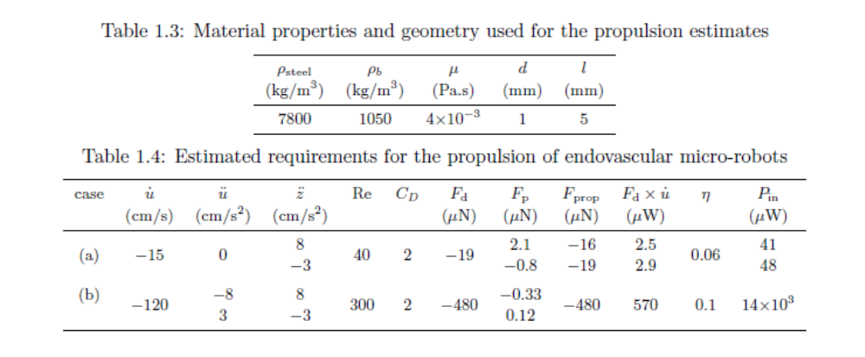

Blood ow within the arterial tree is pulsatile; for adults at rest, the heart rate ranges from 60 to 80 beats per minute. An example of the temporal pulse pro_le is shown in Fig. 1.3(a), where the ow velocity (z_) in the femoral artery of a dog with a mean velocity of 15 cm/s has a forward and reverse peak of 120 and 􀀀16 cm/s, respectively [54]. Relative to a blood ow with displacement of z, the minimum propulsion speed (u_ ) needed for a micro-robot to travel upstream in the arterial tree is the mean blood velocity (__z), which is of the order of 15 cm/s in the femoral artery (see Table 1.2). A more di_cult task for the microrobot is to maintain position without anchoring itself to the blood vessel wall. In this case the micro-robot must be capable of matching the maximum acceleration (u = 􀀀z) and speed (u_ = 􀀀z_) of the blood ow, which are respectively, on the order of 8 cm/s2 and 120 cm/s (see Figure 1.3(b)).
Power and torque needed for propulsion
We will estimate the force (Fprop) required to propel the micro-robot in the following scenarios: (a) travelling upstream at the mean blood velocity (u_ = 􀀀__z = 􀀀15 cm/s, u = 0), and (b) overcoming the maximum acceleration and velocity of the blood pulse (u_ = 􀀀120 cm/s, u = 􀀀z cm/s2). Using the simple assumption of steady-state drag 􀀀1 2_bACDu_ ju_ j, and hydrostatic pressure force _bV z, the equation of motion for a micro-robot is
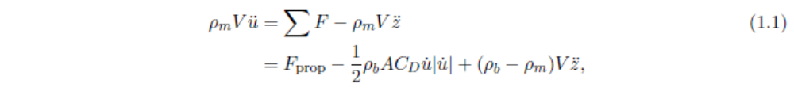
where CD is the drag coe_cient, A is the frontal area, V is volume, _ is density, subscripts b and m denote the blood and the micro-robot, and u is the micro-robot displacement relative to an accelerating frame z attached to the blood ow. The drag coe_cient CD depends on the geometry of the micro-robot and the Reynolds number Re = _bu_d=_, where d is the frontal diameter of the micro-robot, and _ is the viscosity of blood. The micro-robot is assumed to be in the shape of a cylinder with diameter d = 1 mm and length l = 5 mm with density of steel _steel = 7800. Using the ow property of a disk as an estimate, CD is less than 2 for a cylinder with Re in the 40{300 range [91]. The estimated forces are shown in Table 1.4, where we can see that the drag force Fd = 1 2_bACDu_ ju_ j dominates over the forces due to acceleration Fp = V [_mu 􀀀 (_b 􀀀 _m)z]
Table 3 : Required torque and power density
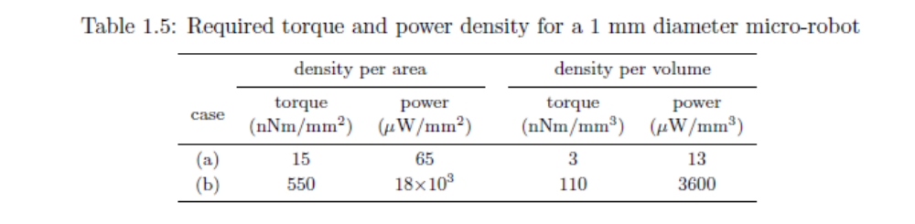

The power required from the micromotor Pin depends on the e_ciency _ of the propulsion mechanism (de_ned as _ = Fpropu_=Pin). It is unclear what propulsion mechanism is most suitable for swimming micro-robots with Re in the 40 { 300 range: at Re= 104, propellers for micro-aerial vehicles (MAVs) have e_ciencies of 0.4 [79], while at the low Re extreme of 10􀀀1, agellar propulsion is predicted to have e_ciencies of the order of 0:008 [39]. Using a logarithmic interpolation between these values, the propulsion e_ciencies at Re=40 and 300 are estimated to be 0.06 and 0.1, respectively. The power required to propel a micro-robot is thus estimated to be 48 _W and 14 mW for case (a) and (b). The required torque _ from the micromotor can be estimated from the operating angular velocity of the propellers. For agellar propulsion with _xed agellum shape [39], the operating angular velocity ! of the propeller is predicted to be

where N_ is the number of wavelengths of the agellar helix, J is the ratio of propulsion speed over agellar wave speed, and K is the ratio of the agellar length over the radius of the vehicle head. Using the parameters for a agellar with relatively high propulsion e_ciency of 0.008 (N_ = 1:5, J = 0:07, and K = 10), the following estimates are obtained for the two cases: (a) ! = 4 _ 103 rad/s and _ = 12 nNm, and (b) ! = 32 _ 103 rad/s and _ = 440 nNm. Since the critical constraint on endovascular microrobots is their cross-sectional dimension, an important metric of comparison for di_erent micromotors is their torque and power density per cross-sectional area. The estimated requirements are shown in Table 1.5.

Literature Review

2.1 Comparison of small motor technologies

Researchers have investigated many di_erent actuation methods for micromotors, utilizing a diverse range of phenomena from electrostatic and magnetic to piezoelectric e_ects. In this section we will examine the characteristics of the above mentioned motor technologies, describing their working principles, scaling laws, current level of performance, and potential for further improvements. Their suitability as micromotors at the 0.1{1 mm scale will be assessed with respect to the performance requirements of endovascular micro-robots discussed in Section 1.2.2.
The comparisons serves to highlight the large torque and power output of piezoelectric ultrasonic motors that make them particularly suitable for applications at the 0.1{1 mm scale. The combined axial-torsional standing-wave (CATS) ultrasonic motor that forms the focus of this thesis is introduced in our discussion of piezoelectric motors; a simple design for CATS ultrasonic motors that has great potential for miniaturization is detailed.
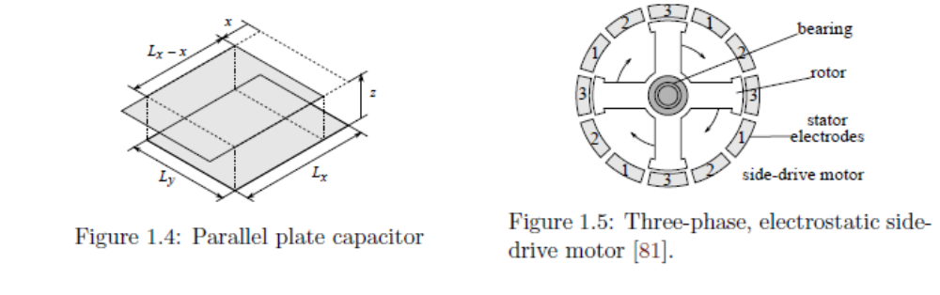
Test
5A
Figure 5 : Parallel plate capacitor and Three-phase, electrostatic side-drive motor

2.1.1 Electrostatic motor
The basic motive force employed in electrostatic actuators arises from the electrostatic interaction between electric charges. A simple example of such an actuator is the parallel plate capacitor (see Fig. 1.3.1). For a constant voltage of V , the potential energy U stored in the capacitor is a function of the parallel x and normal z plate displacements:

where C is the capacitance, Lx and Ly are the plate dimensions, _ is the permittivity of the dielectric layer, and the e_ect of fringing _elds is neglected. The tangential Fx and normal Fz forces tending to realign the plates due to the relative displacements are

where the electric _eld jEj = V=z is limited to jEj < jEbj due to the electric breakdown of the dielectric layer. Since the permittivity _ is a scale independent property, and the scaling law (in terms of linear scale variable L) for the breakdown _eld Eb is known to lie between L􀀀0:5 and L0 [22, 82] (increasing slightly as scale is decreased), the force scaling law for electrostatic actuators is estimated from Eqs.(1.4) to be between L1 and L2. Motor designs
Although parallel plate actuators have limited stroke lengths, they can be used to generate continuous rotary motion by a proper manipulation of charge distributions on a set of stationary electrodes (stator) and free moving electrodes (rotor). Since research on the creation of MEMS micromotors using silicon-based microfabrication techniques began in the 1980s, several electrostatic motor designs have been demonstrated [81, 42]. The commonly reported designs can be broadly classi_ed as variable-capacitance motors, or electrostatic induction motors [56, 52, 26]. Variable-capacitance motors were the earliest successful MEMS electrostatic micromotors. The torque generated by the motor is proportional to the rate of change in the stator-rotor capacitance as a function of rotor position [56, 20]. Three types of variable-capacitance motors that have been reported are: (1) the top-drive motor, where tangential driving forces are developed between the overlapping electrodes on the planar faces of the stator and rotor, (2)
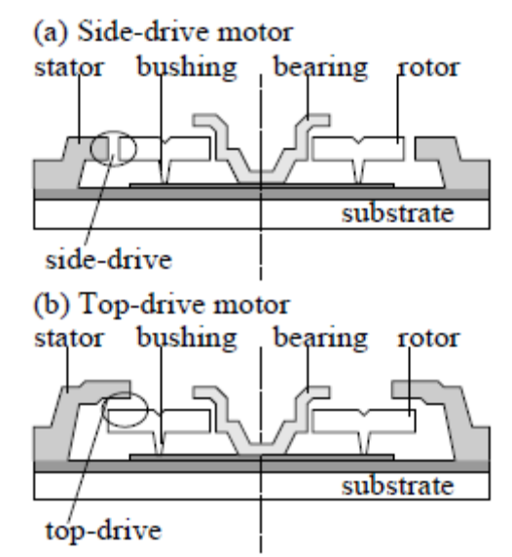
Figure 6 : Side-drive motor

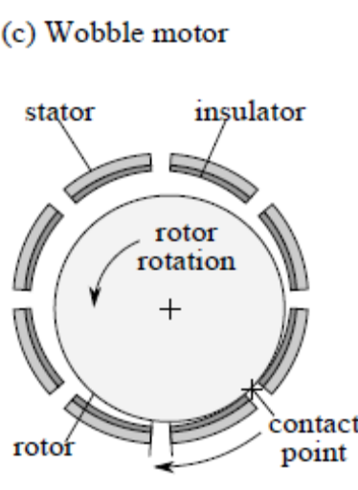
Figure 7 : Wobble motor

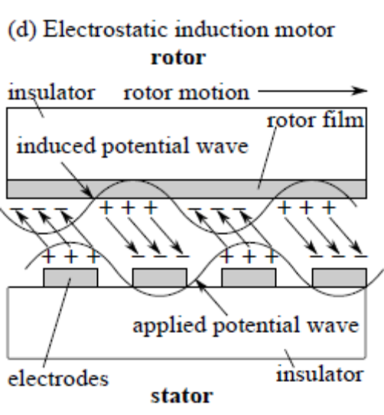
Figure 8 : Stator

2.1.2 Electrostatic motor
The basic motive force employed in electrostatic actuators arises from the electrostatic interaction between electric charges. A simple example of such an actuator is the parallel plate capacitor (see Fig. 1.3.1). For a constant voltage of V , the potential energy U stored in the capacitor is a function of the parallel x and normal z plate displacements.

2.1.3 Electromagnetic motor
Scaling of magnetic forces There are two basic con_gurations for magnetic actuators (see Fig. 1.7), consisting of a current I1 interacting with the magnetic _eld B generated by: (a) another current I2, or (b) a permanent magnet. The magnetic _eld generated by current I2 is

2.1.4 Piezoelectric motor
Scaling of piezoelectric actuators Unlike electrostatic and electromagnetic actuators that employ force _elds acting at a distance, the force used in a piezoelectric actuator arises from the stress and deformation experienced by
piezoelectric materials due to the application of electric _eld within them. The linear model of piezoelectric materials are described by the following constitutive equations [1],

Goals of our research
We have shown that ultrasonic motors have good torque and power densities that make them suitable for applications at the 0.1-1 mm scale; we have also introduced a CATS motor design with pretwisted beam vibration converter that is easier to fabricate and miniaturize. However, details of the torque transfer process in CATS ultrasonic motor and the geometry of pretwisted beams for e_cient vibration conversion are largely unknown. Our goal is thus to understand and model the motor, which will eventually help us design and improve its performance. Although concrete design optimization of a CATS motor is not pursued in this thesis, the e_ects of important design parameters on motor performance are investigated. The operation of pretwisted beam CATS motors may be understood as a combination of two processes: (1) the conversion of axial excitation into coupled axial-torsional motion by the pretwisted beam, and (2) the transfer of rotary motion from the pretwisted beam to the rotor via frictional contact. The results for the second process is general to all CATS motors whether the stator trajectory is generated using vibration converters or torsional transducers. In this thesis, the two processes are investigated separately.

3.1 Stator dynamics
The use of resonance to amplify the stator vibration is crucial to the operation of piezoelectric ultrasonic motors. In order to maximize the e_ciency of the pretwisted beam vibration converter, its axial and torsional resonance frequencies needs to be matched. Moreover, for the motor to be able to reverse its direction of motion, the stator needs to have at least two operating frequencies where the axial-torsional vibration phase lag di_ers by 180_. The analysis of the vibration of pretwisted beams thus forms a major focus of this project. We limit our investigation to pretwisted beams that can be easily fabricated and have bending that is uncoupled with torsion and extension. This means the structures have uniform cross-section geometry, uniform rate of pretwist, uniform material properties, and an axis of twist that coincides with the shear center. With these geometric restrictions, the resonance frequency of a pretwisted beam is inuenced by the beam's cross-sectional shape, rate of pretwist, slenderness, and its tensile and shear modulus. We investigate the use of a one-dimensional beam theory to predict the resonance frequencies of pretwisted beams.

3.2 Stator-rotor interaction
The stator-rotor interface of piezoelectric motors is one of the least understood parts of the motor. Past researchers [63, 64, 36] have simpli_ed the analysis of the interaction by assuming that the vertical position of the rotor is _xed or periodic such that the duration of contact _ can be determined by requiring the net vertical impulse exerted on the rotor to be zero over one stator forcing cycle I

Motor characteristics: Prewtisted beam CATS ultrasonic motor

Overview: Prototypes of pretwisted beam CATS ultrasonic motors were fabricated, and the e_ect of preload and input power were systematically investigated. Characteristics of the motor were determined by measuring their transient speed-time curves, which were used to extract information such as the friction coe_cient and the speed-torque curves. A series of basic prototypes of the pretwisted beam CATS ultrasonic motors was fabricated and tested to determine their characteristics and to help us formulate a model of the motor.
The prototypes consisted of 47.5 mm long pretwisted aluminium beams with rectangular crosssections that are glued to and excited by an axially-poled multi-layer piezoelectric actuator (MLPA). Two geometric parameters were varied: the cross-section aspect ratio1 was varied from 1.44 to 1.93 while keeping the cross-section diagonal2 at 4:8 _ 0:1 mm, and the rate of pretwist (measured as helix angle3) was varied from 18_to 33_. The chief parameters under systematic investigation are the rotor preload and the power input to the MLPA. The motors are characterized by measuring their transient speed-time curve, which is obtained by switching on power input to the MPLA with the rotor initially at rest, letting the rotor accelerate until steady-state speed is reached, then decelerating the rotor to a full stop by switching o_ the power input. The transient speed curve provides a wealth of information about the motor: we can extract the speed-torque curve from the initial acceleration, and the coe_cient of friction between the stator and the rotor from the _nal deceleration. The results show that the motor performance varies considerably depending on the beam geometry, input power, and rotor preload. The power conversion e_ciency of the motor ranged from 3% to 8%, and the maximum torque and speed attained were approximately 0.28 mNm and 1360 rpm, respectively4. The low e_ciency of the prototypes illustrates the importance of an accurate theoretical model that will allow us to optimize the design of the motor. In Chapter 4, predictions of our bouncing-disk model are compared with the experimental observation obtained from similar setups to the ones presented in this chapter.

4.1 Stator dynamics: Vibration of pretwisted beams

Overview: We investigate the accuracy and validity of a warping-function based beam theory in predicting the axial-torsional resonance frequencies of pretwisted beams. We derive a set of criteria for determining when the theory can be applied and when an alternative method is needed. One of the key features of the motor studied in this research is the use of a pretwisted beam as a vibration converter that transforms the linear oscillation input of an axially-poled piezoelectric transducer into the desired motion at the stator tip. An important factor in the design of an e_cient axial-torsional vibration converter is to ensure that the axial and torsional resonance frequencies of the pretwisted beam are matched. The design of our pretwisted beam vibration converter would be signi_cantly aided if the e_ects of various geometric parameters and material properties on the vibration characteristics of pretwisted beams are understood, and thus this forms the main objective of this chapter. There is a large variety of twisted and beam-like structures with extension-torsion coupling. However, for the purpose of the CATS ultrasonic motors we limit our focus to straight beams with a constant rate of pretwist along its axis, constant cross-sectional geometry, and whose bending is uncoupled to torsion and extension (the last restriction limits the geometry such that the centroid and shear center coincides with the axis of pretwist).
The vibration of pretwisted beams has been a subject that has sustained the interest of many researchers due to its importance as a model for aircraft and helicopter rotor blades [72]. However, there are di_culties with adapting existing analytical models to the vibration converters of CATS ultrasonic motors because aircraft rotor blades have a much lower rate of pretwist. Furthermore, these works do not specify the range of pretwist for which the models are valid. In the following paper, we examine a type of model|often found in the literature [71, 40, 83, 48] for the dynamics of pretwisted beams|that accounts for the axial-torsional coupling through the use of the Saint-Venant warping function. Through scaling analysis we derive a set of criteria that allow us to quantitatively determine, when the assumptions of the warping function model becomes invalid. Comparisons with predictions from _nite-element method (FEM) show that the simpli_cations that results from the use of Saint-Venant warping function results in poor prediction of the axial resonance frequency. The results allow us to determine when the design of pretwisted beam vibration converters can be performed using the Saint-Venant function warping function based beam model and when FEM or other methods are required. A potentially suitable beam theory at moderate rates of pretwist is the variational-asymptotic method developed by D.H. Hodges and his colleagues at Georgia Tech and University of Michigan [41, 94]. Note, however, that this method is not explored in this thesis, and its use in future research is discussed in the concluding chapter (Chapter 5).

4.2 Declaration for Thesis Chapter 3
In the case of the article entitled \The axial-torsional vibration of pretwisted beams"1, the nature and extent of me and my co-authors' contribution are as follows:
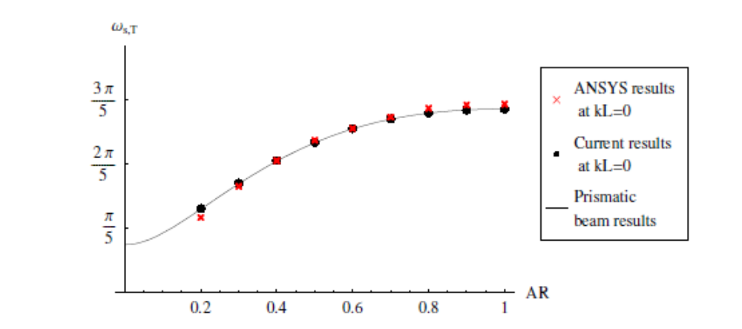
Figure 9 : Graph ANSYS

The results allow us to determine when the design of pretwisted beam vibration converters can be performed using the Saint-Venant function warping function based beam model and when FEM or other methods are required. A potentially suitable beam theory at moderate rates of pretwist is the variational-asymptotic method developed by D.H. Hodges and his colleagues at Georgia Tech and University of Michigan [41, 94].

Figure 10 : Bolt

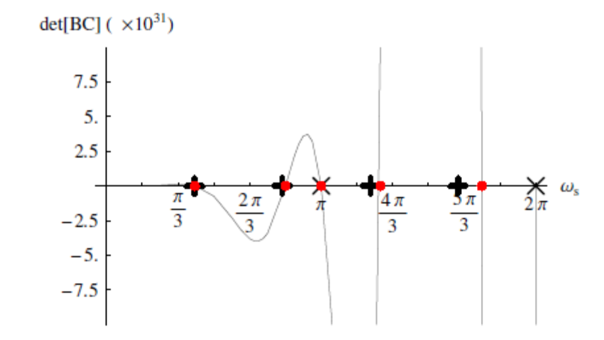
Figure 11 : Graph details

Table 4 : Arteries where endovascular interventions

This is footnote 1

