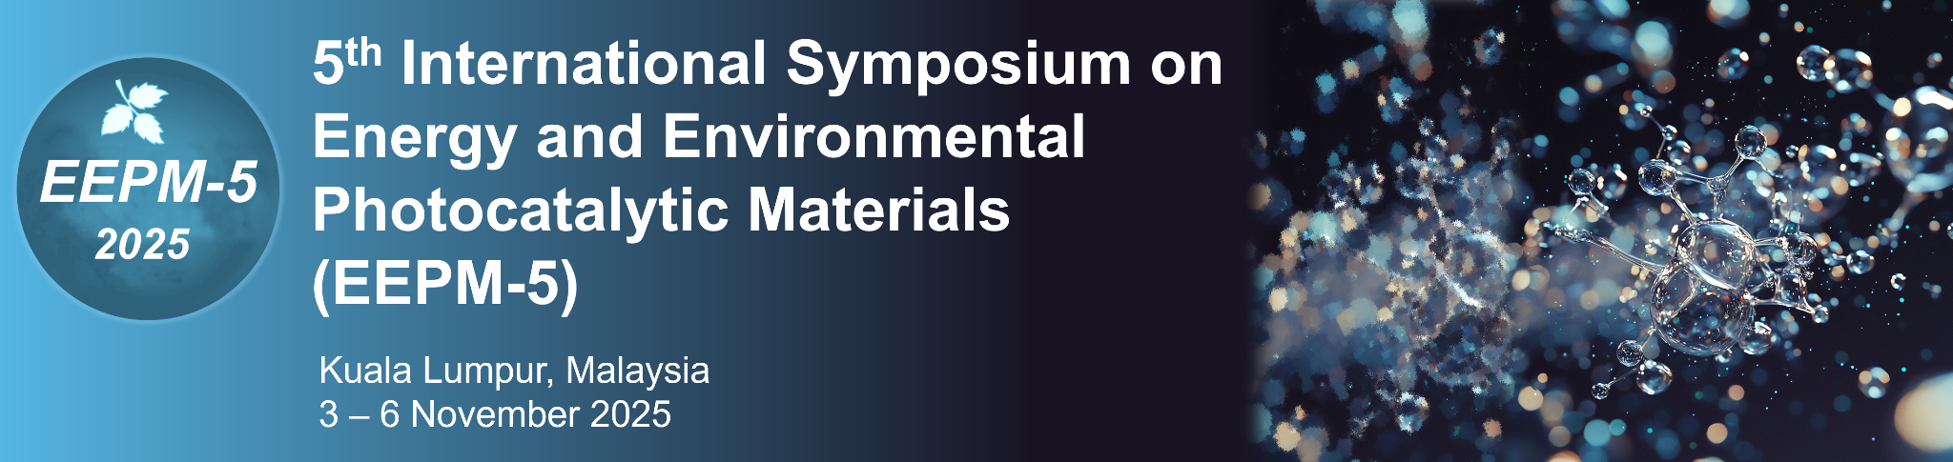

Abstract Submission Form

Email
Designation | Choose one:  ☐ Prof.  ☐ Assoc. Prof.  ☐ Asst. Prof.  ☐ Dr.  ☐ Mr.  ☐ Ms.  ☐ Ir.  ☐ Other (please specify): ________________
First Name (Given Name)
Last Name (Surname)
University / Organization
Status | Choose one:  ☐ Student  ☐ Researcher  ☐ Academic staff  ☐ Industry  ☐ Other (please specify): ________________
Category | Choose one:  ☐ Oral presentation  ☐ Poster presentation
Topic | Choose one:  ☐ Photocatalysis for solar fuels, hydrogen production, and CO₂ reduction  ☐ Photoelectrocatalysis for sustainable energy applications  ☐ Advanced photocatalytic materials for environmental remediation, disinfection and pollutant degradation  ☐ Innovations in semiconductors and hybrid material design  ☐ Mechanistic studies of reaction pathways and charge carrier dynamics  ☐ Industrial applications and the scale-up of photocatalytic technologies  ☐ Computational modelling and machine learning in the design and optimisation of photocatalytic systems  ☐ Others: Please specify

